
Extractives industry

safe drill and blast in surface operations TEMPLATES


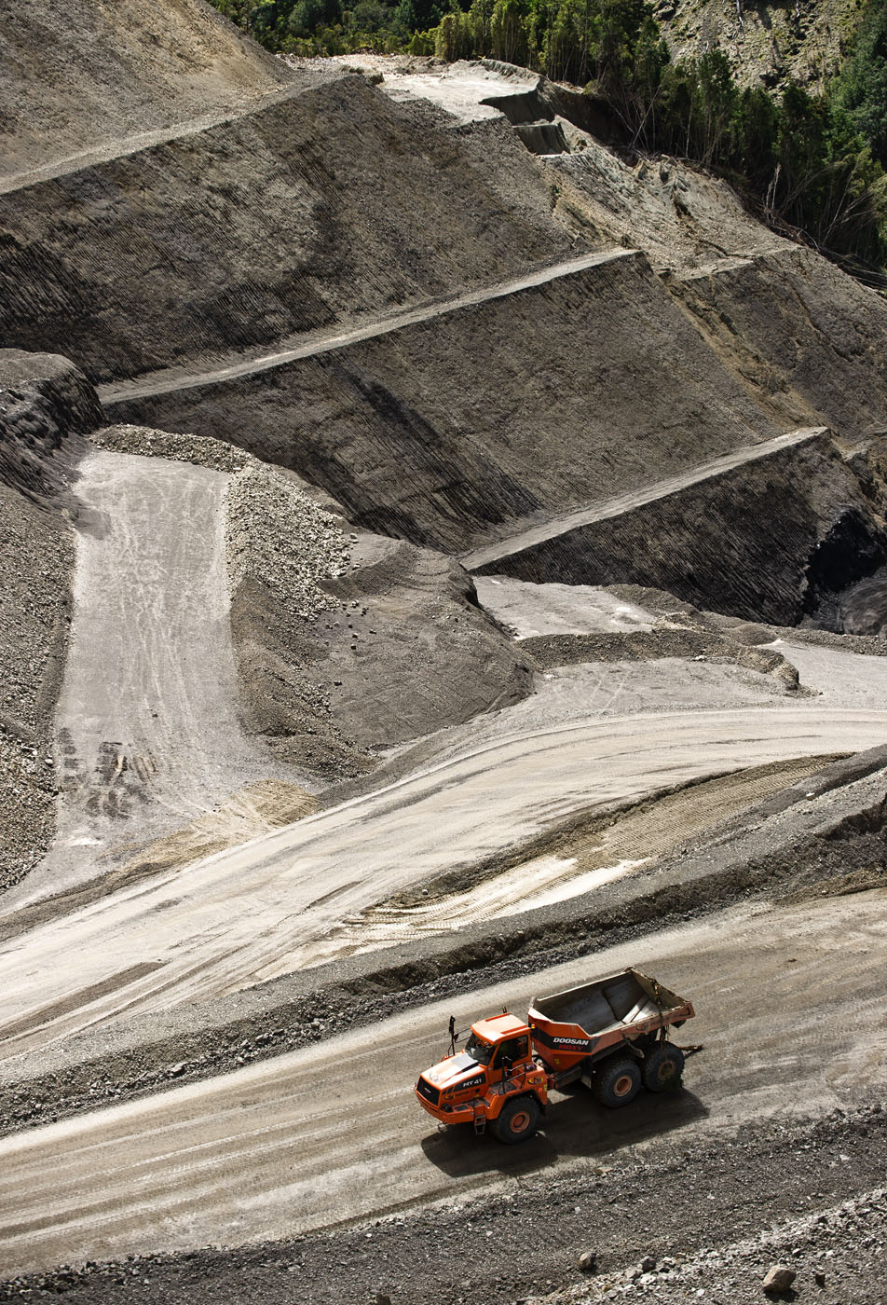

Contents
2
Appendix 1: Separation distances 3
Appendix 2: Audit checklist to AS 2187.2 4
Appendix 3: Explosives Management System templates 10
Blast Specific Risk Assessment Form 14
Managers Blast Checklist 16

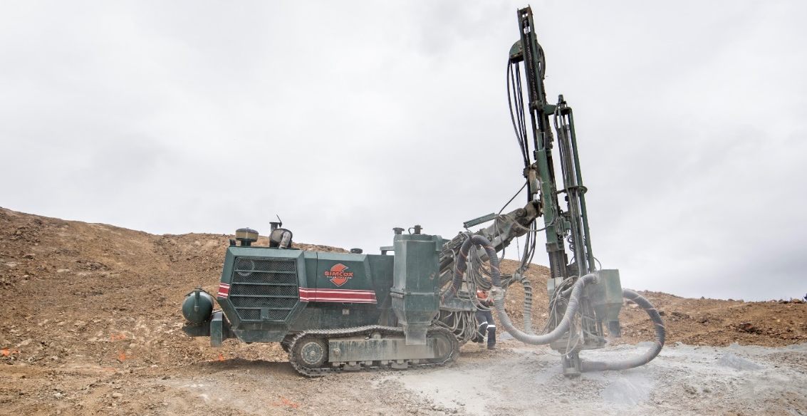

Appendix 1: Separation distances
The following table summarises the separation distances (metres) for the storage of explosives as given in
AS 2187.1:1998.

NEQ stored (kg) | Protected  Works-  Class A | Protected  Works –  Class B  Unmounded | Protected  Works –  Class B  Mounded | Vulnerable facilities | Other storage  Unmounded | Other storage  Mounded | To process building  Unmounded | To process building  Mounded | To AN storage  Unmounted
50 | 25 | 180 | 30 | 180 | 18 | 9 | 18 | 30 | 7
100 | 25 | 180 | 38 | 210 | 23 | 12 | 23 | 38 | 9
200 | 35 | 180 | 52 | 260 | 29 | 15 | 29 | 47 | 11
300 | 45 | 180 | 68 | 300 | 33 | 17 | 33 | 54 | 13
400 | 55 | 180 | 82 | 330 | 36 | 18 | 36 | 59 | 14
500 | 63 | 180 | 95 | 360 | 39 | 20 | 39 | 64 | 15
1000 | 100 | 180 | 150 | 450 | 48 | 24 | 53 | 80 | 18
1500 | 135 | 200 | 200 | 510 | 55 | 28 | 66 | 92 | 22
2000 | 160 | 240 | 240 | 560 | 61 | 31 | 78 | 105 | 23
2500 | 185 | 280 | 280 | 610 | 66 | 33 | 90 | 110 | 25
3000 | 205 | 305 | 305 | 650 | 70 | 35 | 105 | 120 | 26
4000 | 235 | 350 | 350 | 710 | 77 | 39 | 130 | 130 | 29
5000 | 255 | 380 | 380 | 760 | 83 | 42 | 140 | 140 | 31
7500 | 295 | 435 | 435 | 870 | 94 | 47 | 155 | 155 | 35
10000 | 320 | 480 | 480 | 960 | 105 | 52 | 175 | 175 | 39
15000 | 370 | 550 | 550 | 1100 | 122 | 61 | 200 | 200 | 45
20000 | 405 | 610 | 610 | 1220 | 135 | 66 | 220 | 220 | 49
25000 | 435 | 650 | 650 | 1300 | 145 | 71 | 235 | 235 | 53
30000 | 460 | 690 | 690 | 1380 | 150 | 75 | 250 | 250 | 56
40000 | 510 | 760 | 760 | 1520 | 165 | 83 | 275 | 275 | 62
50000 | 550 | 820 | 820 | 1640 | 180 | 89 | 295 | 295 | 67
75000 | 625 | 940 | 940 | 1880 | 205 | 103 | 340 | 340 | 77
100000 | 690 | 1040 | 1040 | 2080 | 225 | 115 | 375 | 375 | 84
120000 | 730 | 1100 | 1100 | 2200 | 240 | 120 | 395 | 395 | 89
140000 | 770 | 1160 | 1160 | 2320 | 250 | 125 | 420 | 420 | 94
160000 | 810 | 1220 | 1220 | 2440 | 265 | 135 | 435 | 435 | 98
180000 | 840 | 1260 | 1260 | 2520 | 275 | 140 | 455 | 455 | 105
200000 | 870 | 1300 | 1300 | 2600 | 285 | 145 | 470 | 470 | 110
250000 | 940 | 1400 | 1400 | 2800 | 305 | 155 | 510 | 510 | 115

NEQ = net explosive quantity, i.e., net quantity of explosive in the article or substance, excluding other constituents.

Appendix 2: Audit checklist to AS 2187.2
Blast site
Requirement | AS 2187.2 | Findings
Area is demarcated and clearly identified from other activities on site. | s6.1.5
A non-work zone established around the blast site for non-blasting related activities. | s6.1.5
Restricted access to the blast site is enforced. | s7.2
Face and/or high-wall are stable, and areas of potential risk identified  and controlled. | s6.1.4
Sufficient lighting provided when activities are undertaken at night. | s6.1.1

Pre-charging activities
Requirement | AS 2187.2 | Findings
Blastholes are checked for depth, blockages, water etc. and non-conforming holes are identified. | s6.1.7
Appropriate risk mitigation process are undertaken to manage non-conforming blastholes. | s6.1.7
Blasthole temperature readings are routinely undertaken in areas of  hot or reactive ground. | s12.6.1
Monitoring equipment, where required (vibration, overpressure and fume detection) is located in  appropriate locations. | Good practice

Explosives selection
Requirement | AS 2187.2 | Findings
Explosives used are within  manufacturer’s shelf life. | Hazardous Substances Regs
Explosives used are appropriate for the required undertaking. | s4.11

Traffic Management
Requirement | AS 2187.2 | Findings
Traffic instructions, when required, posted. | s5.2.2
Blast site is made safe for the operations of explosives vehicle i.e., ramps not too steep, sufficient turning provisions etc. | s5.2.2
Vehicle spotters are available and used when circumstances required. | Good Practice

Charging activities
Requirement | AS 2187.2 | Findings
All explosives are kept secure until ready for use. | s6.3.3
Explosives are handled in a safe manner and in accordance with  operating procedures. | Site HSMS
Explosives that have been laid out for use are kept away from likely contact with vehicles and in a way  that likelihood of being lost down a hole is minimised. | s6.5.1
Primers and detonators are not made ready for use until needed. | s6.3.3
Appropriate level of supervision is in place throughout the activity. | Good Practice
Primers are lowered and placed in blastholes in accordance with procedures.  Note: Be aware of persons allowing primer assemblies to free fall down the blasthole and failure to place primer in charged column as per procedures. | s7.4.4
Blastholes are loaded as per activity procedure.  Note: Most loading with hose requires that the hose is lowered down the hole and withdrawn up the hole as the column is being loaded. Lazy hose operators will just place the hose at the top of the  hole. | Good Practice
Detonator down-lines are secured in a way that minimises likelihood of being lost in blasthole. | s6.5.1
Charge height is measured, and necessary remedial action taken if not to requirement. | Good Practice
Column rise is measured, and necessary action taken if not to requirement. | Good Practice
Housekeeping is undertaken as required including the placement of surplus detonators and primers into secure explosives vehicle. | Good Practice
Due care is undertaken during stemming to prevent loss of detonator down-line and with downline being cut off with equipment such as stemming loader.  Note: There have been several high potential incidents where lack of care by person operating stemming loader has resulted in primers being run over and crushed, downlines cut off or caught on equipment and stretched to breaking. | Good Practice

Tie-in of shot
Requirement | AS 2187.2 | Findings
Connections between down-line detonators to surface delay detonators (where applicable) undertaken in accordance with procedures.  Note: Some surface delay  detonator connectors require to be clipped in with tails facing in specific direction, or connections to be done in a specific manner. | Good Practice
Connections between down-line detonators and surface communication cables (where applicable) undertaken as per  procedures. | Good Practice
Appropriate checks are undertaken to ensure all lines have been connected and connected correctly.  Note: It is suspected that many of the occurrences of misfires are that thorough checks, to ensure that all connections have been undertaken, have not occurred. It is generally  accepted that the nominated Shotfirer should walk the shot and part of his checks are to ensure, as far as reasonably practicable, that the tie in is complete and correct. | Good Practice

Pre-shot initiation activities
Requirement | AS 2187.2 | Findings
Any initiation equipment checks that are required for the initiation of the shot are undertaken. | Site HSMS
Environmental conditions (wind cloud cover etc) are accessed as suitable for the activity to proceed  or not. | s6.1.4
Blast exclusion zones established and maintained.  Note: There may be separate exclusion zones for flyrock and blast fumes. | s8.3
All necessary area evacuations are undertaken, and evacuation areas checked to ensure all persons have  evacuated. | s8.3
All required communication  notifications undertaken. | s8.3
Blast guards briefed and posted to their nominated control points. | s8.3
Communication between person initiating the shot and blast guards established. | s8.3
All stakeholders in the activity agree that it is safe to proceed with the initiation of the shot. | s8.3
Safe place for the person initiating the shot is identified. | s8.3
Final warning signals (sirens or other) understood. | s8.3

Post-blast activities
Requirement | AS 2187.2 | Findings
All blast guards remain in place and prevent entry into exclusion zone until ‘all clear’ has been given.  Note: Post-blast fumes may not always be immediately evident after the initiation of the shot. These may take minutes to be visible. | s9.1.2
Shotfirer undertakes checks of blast (once dust and fume has dissipated and it is safe to do so) to ensure the site is safe for entry and that any identifiable misfires (if any) are noted and managed. | s9.1.2
Post blast documentation  completed. | Site PHMP

General comments:

--------------------------------------------------------------------------------------------------------------------------------------------------
------------------------------------------------------------------------------------------------------------------------------------------------------------------------------------------------------------------------------------------------------------------------------------------------------------------------------------------------------------------------------------------------------------------------------------------------------
--------------------------------------------------------------------------------------------------------------------------------------------------

Appendix 3: Explosives Management System templates

WHOLE of SITE EXPLOSIVES and BLASTING RISK ASSESSMENT

Mine: |  | Team members:
 |  | Shotfirer representative:
To be completed for overall site and reviewed periodically. |  | Date:
Category |  |  | Risk |  |  | Audit Observations - Controls
Category |  |  | H | M | L
Legislation
Competencies | Has a competent Shotfirer been engaged to conduct blasts
 | Do all persons having unsupervised access to explosives or explosive precursors have a security clearance
Licences | If explosives are to be stored, are they stored in licenced premises in accordance with Health and Safety at Work (Hazardous Substances) Regulations 2017, and AS2187
 | Has the risk of theft been considered and a security plan been drafted (if required)
 | Is the site allowed to blast pursuant to its resource consent

Planning
Notification | Has community consultation taken place with neighbours prior to blasting
 | Has an exclusion zone been identified
 | Has an agreed notification process to alert the community, employees & visitors that blasting will take place been developed? (Signage, letter drop, verbal, sirens etc.)
 | Has a geotechnical assessment been undertaken to identify potential hazards (Cavities, jointing, faults, weathered material etc.)
Blasting Hazards
Flyrock | Do procedures exist to control flyrock to a minimum (Stemming, loading, overcharging.)
 | Do procedures exist to ensure blast designs are ‘signed off’
 | Do controls include laser profiling & bore tracking
 | Does the exclusion zone consider all possible flyrock scenarios
Vibration | Have calculations been completed to model potential vibration levels
 | Are monitoring devices being installed at agreed locations
Noise (overpressure) | Have calculations been performed to model potential noise/overpressure levels
 | Are monitoring devices being installed at agreed locations
Dust & fumes | Are adverse weather conditions considered in the modelling
 | Is dust and or fume monitoring required at close residences
Traffic | Has public and mine traffic been considered in relation to exclusion zones
 | Has a communication strategy been developed to manage all traffic, clearing of exclusion zones and firing requirements
Managing the Blast Cycle
Transport | Are vehicles transporting explosives licenced (if on a public road) or maintained to a similar standard (on a mine site)
 | Are procedures in place to exclude non-essential personnel from the blast area (signage, removal of production equipment)
 | Will selected transport routes keep explosives vehicles separated from production equipment as much as possible
 | The site has considered its response to a fire situation where explosives may be present
Loading | Are procedures in place to control the amount of product that is loaded into each hole
 | Are procedures in place to manage persons working near high-wall benches
 | Are all high-walls protected by a structural barrier or a bund
 | Is the site going to have to manage wet shots (ground water and surface water)
Firing | Are procedures in place to manage the clearing of exclusion zones
 | Are procedures available to manage ‘misfires’
 | Does the misfire procedure reference AS2187
 | Are procedures in place to ensure that anything capable of generating a fire is not carried out within 10 m of explosives
Loss of explosives | Has the security of the site been considered, particularly with respect to ‘sleeping shots’
 | Has the site got systems in place to identify the loss of explosives and the reporting of the loss to the police and the regulator
Documentation
 | Will the site be requiring blast specific risk assessments
 | Will the site be requiring SWMS to cover all activities relating to blasting
 | Will the site be requiring a copy of the blast report at the conclusion of the shot
 | Are there copies of explosive legislation, standards, and codes available for persons to refer to:
- Health and Safety at Work (Mining and Quarrying) Regulations 2016
- Health and Safety at Work (Hazardous substances) Regulations 2017
- AS 2187 (storage, transport and use of explosives
- NZ Extractives Industry Safe Drill & Blast Code of practice

Blast Specific Risk Assessment Form
Site: |  |  | Date shot commenced: |  |  |  | Date fired: |  |  |  |  | Shot Number:
Company performing Drilling: |  |  |  |  |  |  | Name of Driller:
Company performing Blasting: |  |  |  |  |  |  | Nominated Shotfirer:
Person supervising drill and blast for mine/quarry:
(To be completed before work commences) |  |  |  |  | Y/N | (To be completed before firing commences) |  |  |  |  |  |  |  | Y/N
Access / layout |  | Is the access road to the bench adequate (Gradient, edges protected, surface) |  |  |  | Pre-Initiation |  |  | Has loading occurred as per the blast design (no overloading, slumping, lost holes)
 |  | Is there appropriate distance from the back row of holes to the high-wall (> ½ the face height) |  |  |  |  |  |  | Has an exclusion zone been established
 |  | Have all high-walls been scaled and confirmed safe |  |  |  |  |  |  | Is the Shotfirer able to fire the shot without any known risks to people or infrastructure
 |  | Does everyone have SWMS to cover their work
 |  |  |  |  |  | Agreed Alterations to Design (both parties sign to accept changes) |  |  |  | Shotfirer -
Mark-out |  | Has the face been inspected from below  (No undercuts, overhangs, back break) |  |  |  |  |  |  |  | Manager -
 |  | Is the shot surface reasonably smooth & clear of trip hazards |  |  |  | Hazards Identified and Implemented Controls (record actions)
 |  | Are all edges protected by a structural barrier or a bund |  |  |  | 1.
 |  | Have communication systems been confirmed with the quarry operator |  |  |  | 2.
Drilling |  | Can the drill rig drill all holes perpendicular to the face |  |  |  | 3.
 |  | Can all holes be drilled on gradients within the capabilities of the drill rig |  |  |  | SIGN-OFF (All members of blast cycle team to sign off on risk assessment.)
 |  | Is there an exclusion zone around the boom of the rig |  |  |  | 1.
 |  | Have all water sources been identified and drawn to the Shotfirer’s attention |  |  |  | 2.
Loading |  | Has the blast area been defined with signage and all non-essential equipment and people removed |  |  |  | 3.
 |  | Can all holes be loaded without a person having to breach the structural barrier or bund to load |  |  |  | 4.
 |  | What fall protection devices will be used  ( ) |  |  |  | Confirmation of completed Risk Assessment by Manager |  |  |  |  | (signature)

Managers Blast Checklist

Site: |  | Date shot commenced: |  | Date & time fired: |  | Shot Number:
Company performing drilling: |  |  |  | Name of Driller:
Company performing blasting: |  |  |  | Nominated Shotfirer:
Person supervising drill and blast for mine/quarry:

Preparation: |  |  |  |  or N/A
A copy of the driller’s SWMS and / or contractor management plan has been obtained and reviewed
A copy of the Shotfirer’s SWMS and /or Contractor Management Plan has been obtained and reviewed
All persons have been inducted onto site
A face & bench stability inspection has been conducted to identify any issues
The blast design has been completed in consultation with the Shotfirer and agreed upon
A blast specific risk assessment has been completed
Edge protection is in place prior to mark out (fencing with structural capability or bunded)
Measure from the back row of holes to the face behind to verify that final bench width will be as designed, taking account of back break, edge protection required etc.
Drilling:
Drilling equipment has been inspected and confirmed ‘fit for purpose’
If the shot is laser profiled, the results have been reviewed and accepted
If the shot is bore tracked the results have been reviewed and accepted
A copy of the final drill log has been supplied and reviewed with the Shotfirer
Where a front hole has deviated toward the face, what is the allowable minimum burden before the load plan is modified
Is the actual burden along the length of each front hole within the allowable minimum burden
Has the driller done a risk assessment prior to drilling to ensure the bench being drilled is safe? i.e. Back break, undercut face below or above the driller, steepness of ground
Blasting: | or N/A | Neighbours Names: | “How Notified”  (Verbal, mail etc.)
All neighbours have been notified as per Resource Consent or agreed requirements (record details) |  | 1.
Environmental monitors have been positioned |  | 2.
Is the blast going to occur between allowable hours |  | 3.
Weather conditions are confirmed O.K. to blast |  | 4.
Blast camera is in position to record shot |  | 5.
Sentries have been positioned |  | 6.
All persons on site have been accounted for and are outside of exclusion zone
Control handed over to Shotfirer |  | Monitor Locations:
All audible warning sirens have been sounded prior to blast |  | 1.
Reconciliation between design and actual explosives used, and powder factor, completed and reviewed with Shotfirer |  | 2.
Has the Exclusion zone been calculated for the shot and is it appropriate for the blast as charged |  | 3.
Post Blast Inspection: |  | 4.
No misfires have been identified |  | 5.
Misfires have been identified, recorded, and dealt with in accordance with an approved ‘misfire’ procedure |  | 6.
Shotfirer has handed site back to ‘mine operator’
No environmental exceedances identified |  | Regulatory Notifications:
Any blast concerns are noted on the blast plan & report |  | 1.
Regulators have been notified of reportable incidents or exceedances (Flyrock, misfire, faulty product, exceedances) |  | 2.
A copy of the blast plan & record has been provided to the mine/quarry Operator |  | 3.

